Used Workflows

# Overview

It fetches all the workflows which are mapped on VRA as a XaaS blueprints.

# Goal

It is prepared to systemize the VRO as one can distinguish between used and unused workflow.

# Solution/Logic Design

Fetch all the XaaS blueprints, get their name and set the type to “XaaS”

vcacCafeHost

Fetch IDs(workflowID) of the provisioning workflow of the blueprint

Array.push(blueprintname,type)rest values would be null

If (provisioning workflow != null)

If no

If yes

Get provisioning workflow Server.getWorfklowWithID

(ProvisioningWorkflowID) and fetch linked workflow from the items

if No

If (linked workflow != null)

If yes

get name and id of the linked workflow,set type to “linked” and fetch linked’s linked workflow

Call action”getLinkedworkflowfromID”

If linked’s linked workflow among items != null then fetch its name

linkedMap.put(LinkedWorkflow id,LinkedWorkflow details)and array.push(blueprint,type,provisioning workflow name,provisioning workflow id,linked workflow)

Iterate the linkedMap and linkedArray.push(blueprint,type,linked workflow name,id,linkedlinkedworkflow)

FETCH resource actions and set the type = “Resource actions”

Array.concat(linkedArray)

Write data to the file through action “writeDataToFile”,attach it with the mail and send the mail through “Send mail”

end

# Unused Workflow Properties

* Provisioning Workflow Name – Name of the workflow which are mapped on VRA
* Service Blueprint – XaaS blueprint and Resource actions to which the workflow has been mapped.
* Type - type of the workflow among XaaS, Linked or Resource Action
* Provisioning Workflow id – ID of the provisioning workflow
* Linked workflow – workflow linked to Provisioning Workflow.

Dependencies

# Related Actions

* WriteDataToTheFile – It writes the requested data to the file.
* ValidateEmail – It validates the email address.
* GetLinkedWorkflowWithId – it is returning the array of linked workflow of a Parent workflow along with its id with the help of the Parent workflow id.

# Related Workflows

* Send Mail – It attaches the file to the mail and send it to the specified requester.

# Related Configuration Elements

* fromName – Sender’s Name
* fromAddress – Sender’s Address
* vcaccafeHost – It is the host through which VRO connect with VRA to fetch the required data.
* smtpHost – with which one will be able to connect to the server to send the mail.
* CcAddress – it includes other member’s mail address to whom requester wants to send the mail.
* smtpPort - with which one will be able to connect to the server to send the mail.

# Attributes

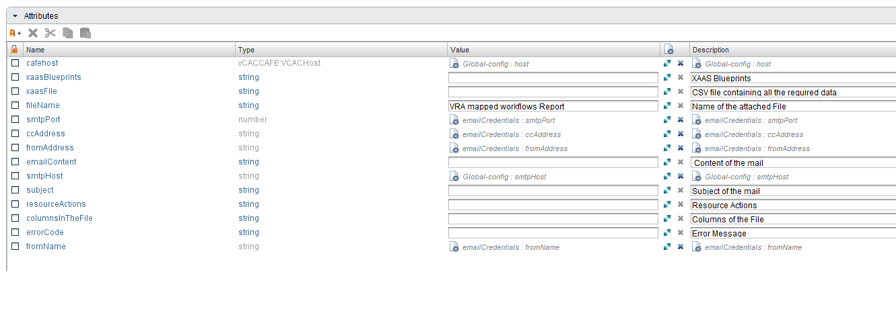

# Inputs

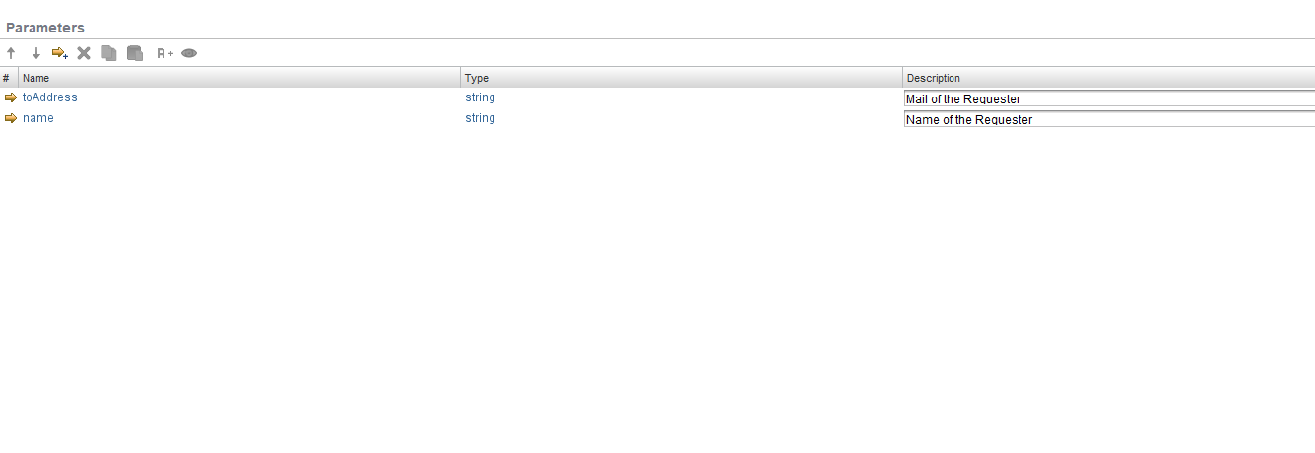

# Future Scope

The workflow can to extended to:

* to fetch more linked workflows to get more and more used workflows.